
Oct – 2026
ASSIGNMENT – 2
Course Code : CSA43
Course Name : INTERNET PROGRAMMING
Name : Narravula Navya Sri
Reg No. : 192324220
Max Marks: 50
Answer all the Questions

1 | Develop a JavaScript program using DOM manipulation and Regular Expressions to validate student name, email ID, mobile number and password during online registration. Display appropriate error messages without reloading the webpage. | (10) | (CO2) | (BL3)
2 | An e-commerce dynamic product search webpage using JavaScript DOM and AJAX for to Retrieve product details in JSON format from the server and display the matching products dynamically as the user enters a product name. | (10) | (CO2) | (BL4)
3 | Discuss the significance of the XMLHttpRequest object, its ready State properties and callback methods. Illustrate the working of AJAX using a suitable JavaScript program . | (10) | (CO2) | (BL3)
4 | An engineering college plans to develop a Student Management System using TypeScript to manage student information, including name, register number, department and marks. Develop a TypeScript program using a class and object to represent student details. Include properties, a constructor and a method to display student information. | (10) | (CO2) | (B4)
5 | Develop a JavaScript-based form validation system for an online banking application. Use Regular Expressions to validate account number, mobile number and email ID. | (10) | (CO1) | (BL3)

1. Student Registration Form Validation Using JavaScript, DOM and Regular Expressions

Aim
To develop a JavaScript program using DOM manipulation and Regular Expressions to validate student name, email ID, mobile number and password during online registration without reloading the webpage.

Program
<!DOCTYPE html>
<html>
<head>
<title>Student Registration</title>
</head>
<body>
<h2>Student Registration Form</h2>
<form id="registerForm">
Student Name:
<input type="text" id="name">
<span id="nameError" style="color:red"></span>
<br><br>

Email ID:
<input type="text" id="email">
<span id="emailError" style="color:red"></span>
<br><br>

Mobile Number:
<input type="text" id="mobile">
<span id="mobileError" style="color:red"></span>
<br><br>

Password:
<input type="password" id="password">
<span id="passwordError" style="color:red"></span>
<br><br>

<button type="submit">Register</button>
</form>
<h3 id="result" style="color:green"></h3>
<script>
document.getElementById("registerForm").addEventListener("submit", function(event) {
event.preventDefault();
let name = document.getElementById("name").value;
let email = document.getElementById("email").value;
let mobile = document.getElementById("mobile").value;
let password = document.getElementById("password").value;
let valid = true;
// Regular Expressions
let namePattern = /^[A-Za-z ]{3,30}$/;
let emailPattern = /^[a-zA-Z0-9._%+-]+@[a-zA-Z0-9.-]+\.[a-zA-Z]{2,}$/;
let mobilePattern = /^[6-9]\d{9}$/;
let passwordPattern = /^(?=.*[A-Z])(?=.*[a-z])(?=.*\d)(?=.*[@#$\%^{\&}+=!]).8,$/;
// Name Validation
if (!namePattern.test(name)) {
document.getElementById("nameError").innerHTML = "Invalid name";
valid = false;
} else {
document.getElementById("nameError").innerHTML = "";
}
// Email Validation
if (!emailPattern.test(email)) {
document.getElementById("emailError").innerHTML = "Invalid email";
valid = false;
} else {
document.getElementById("emailError").innerHTML = "";
}
// Mobile Validation
if (!mobilePattern.test(mobile)) {
document.getElementById("mobileError").innerHTML = "Enter valid 10-digit mobile number";
valid = false;
} else {
document.getElementById("mobileError").innerHTML = "";
}
// Password Validation
if (!passwordPattern.test(password)) {
document.getElementById("passwordError").innerHTML =
"Minimum 8 characters with uppercase, lowercase, number and special character";
valid = false;
} else {
document.getElementById("passwordError").innerHTML = "";
}
// Final Result
if (valid) {
document.getElementById("result").innerHTML =
"Registration Successful!";
} else {
document.getElementById("result").innerHTML = "";
}
});
</script>
</body>
</html>

Regular Expressions Used

Field | Regular Expression | Purpose
Name | ^[A-Za-z ]{3,30}$ | Allows alphabets and spaces
Email | ^[a-zA-Z0-9._%+-]+@[a-zA-Z0-9.-]+\.[a-zA-Z]{2,}$ | Validates email format
Mobile | ^[6-9]\d{9}$ | Validates 10-digit Indian mobile number
Password | ^(?=.*[A-Z])(?=.*[a-z])(?=.*\d)(?=.*[@#$\%^{\&}+=!]).8,$ | Checks password strength

Output
Case 1: Valid Details
- Name: Arun Kumar
- Email: arun@gmail.com
- Mobile: 9876543210
- Password: Arun@123
Output: Registration Successful!
Case 2: Invalid Details
- Name: 123
- Email: arun@gmail
- Mobile: 12345
- Password: abc
Output: Appropriate error messages are displayed near each field.

Result
Thus, the student registration form is successfully validated using JavaScript, DOM manipulation and Regular Expressions without reloading the webpage.
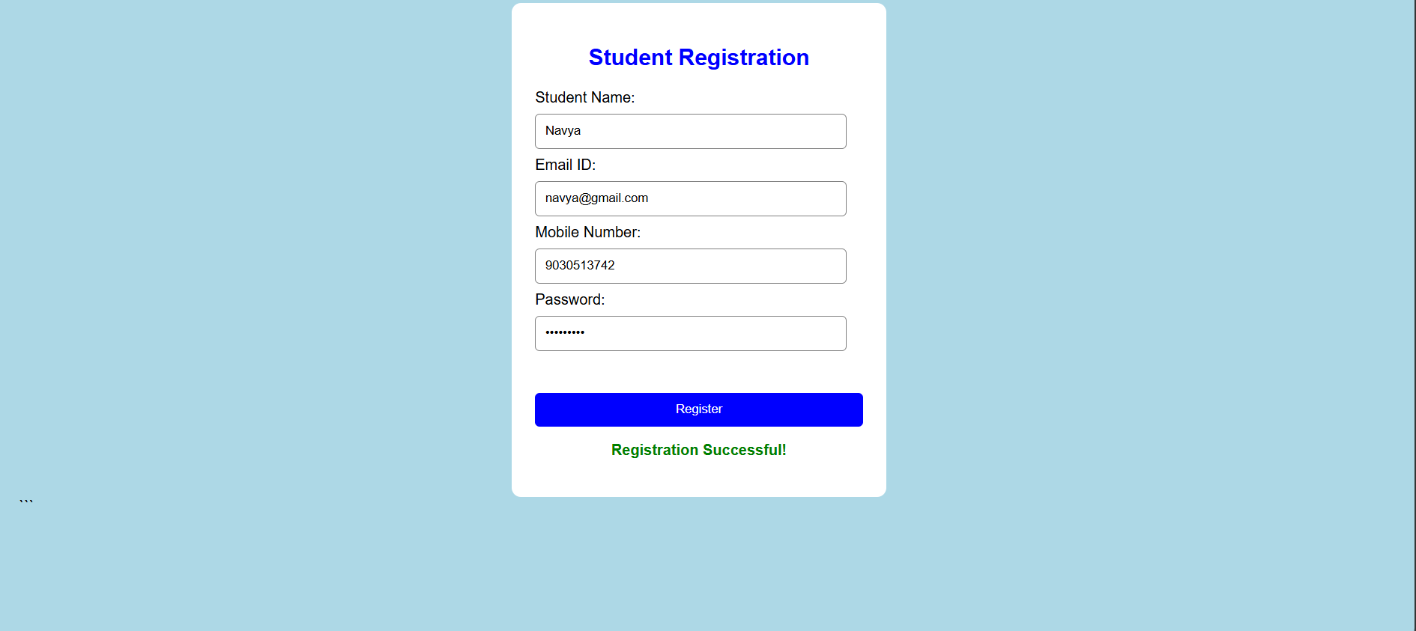

2. E-Commerce Dynamic Product Search Using JavaScript DOM and AJAX

Aim
To develop an e-commerce dynamic product search webpage using JavaScript DOM and AJAX to retrieve product details in JSON format from the server and display matching products dynamically as the user enters a product name.

Program
HTML and JavaScript Code
<!DOCTYPE html>
<html>
<head>
<title>Product Search</title>
</head>
<body>
<h2>E-Commerce Product Search</h2>
<input type="text" id="search" placeholder="Enter product name">
<div id="products"></div>
<script>
// Sample server JSON data
let productData = [
{id: 1, name: "Laptop", price: 50000},
{id: 2, name: "Mobile", price: 20000},
{id: 3, name: "Headphones", price: 1500},
{id: 4, name: "Keyboard", price: 1000},
{id: 5, name: "Mouse", price: 500}
];
// AJAX Request Simulation
document.getElementById("search").addEventListener("input", function() {
let searchValue = this.value;
let xhr = new XMLHttpRequest();
xhr.open("GET", "products.json", true);
xhr.onload = function() {
if (xhr.status === 200) {
let products = JSON.parse(xhr.responseText);
displayProducts(products, searchValue);
}
};
xhr.onerror = function() {
document.getElementById("products").innerHTML =
"Error loading products";
};
xhr.send();
});
// Display Matching Products
function displayProducts(products, searchValue) {
let output = "";
let filteredProducts = products.filter(function(product) {
return product.name.toLowerCase().includes(searchValue.toLowerCase());
});
filteredProducts.forEach(function(product) {
output += "<h3>" + product.name + "</h3>";
output += "<p>Price: ₹" + product.price + "</p>";
});
if (output === "") {
output = "No matching products found";
}
document.getElementById("products").innerHTML = output;
}
</script>
</body>
</html>
Sample JSON File (products.json)
[
{"id":1, "name":"Laptop", "price":50000},
{"id":2, "name":"Mobile", "price":20000},
{"id":3, "name":"Headphones", "price":1500},
{"id":4, "name":"Keyboard", "price":1000},
{"id":5, "name":"Mouse", "price":500}
]

Note: Save both files in the same folder and run them using a local web server. The JSON file is retrieved through AJAX.

Output
Search: Laptop
Displayed Result:
- Laptop
- Price: ₹50000
Search: Mobile
Displayed Result:
- Mobile
- Price: ₹20000
Search: Camera
Displayed Result:
- No matching products found

Explanation
- The user enters a product name in the search box.
- The input event detects the entered text.
- XMLHttpRequest sends an AJAX request to the server.
- The server returns product details in JSON format.
- JSON.parse() converts JSON data into JavaScript objects.
- The filter() method finds matching products.
- DOM manipulation displays the products dynamically without refreshing the page.

Result
Thus, the dynamic e-commerce product search webpage is successfully developed using JavaScript DOM and AJAX.


3. Significance of XMLHttpRequest Object, Ready State Properties and Callback Methods

Aim
To discuss the significance of the XMLHttpRequest object, its readyState properties and callback methods, and illustrate the working of AJAX using a suitable JavaScript program.

1. Introduction to AJAX
AJAX stands for Asynchronous JavaScript and XML.
It is a technique used to exchange data between a browser and a web server without reloading the entire webpage.
AJAX can work with different data formats such as:
- JSON
- XML
- HTML
- Plain Text

2. Significance of XMLHttpRequest Object
The XMLHttpRequest (XHR) object is a built-in JavaScript object used to communicate with a web server asynchronously.
Important uses:
- Sends HTTP requests to the server.
- Receives data from the server.
- Updates webpage content without reloading.
- Supports GET and POST methods.
- Handles asynchronous communication.
- Supports response formats such as JSON, XML and text.

3. readyState Properties
The readyState property represents the current state of an AJAX request.

Value | State | Description
0 | UNSENT | XMLHttpRequest object is created.
1 | OPENED | The open() method is called.
2 | HEADERS_RECEIVED | Server response headers are received.
3 | LOADING | Response data is being downloaded.
4 | DONE | Request is completed.

Important: When readyState == 4 and status == 200, the request has completed successfully.

4. Callback Methods
Callback methods are functions executed automatically when a particular event occurs during AJAX communication.
Important callback methods include:
1. onreadystatechange
Executes whenever the readyState value changes.
2. onload
Executes when the request is successfully completed.
3. onerror
Executes when a network error occurs.
4. onprogress
Executes while response data is being received.
5. ontimeout
Executes when the request exceeds the specified timeout.

5. Working of AJAX
The working process of AJAX is:
- User performs an action on the webpage.
- JavaScript creates an XMLHttpRequest object.
- The open() method specifies the request method and URL.
- The send() method sends the request to the server.
- The server processes the request.
- The server sends the response.
- JavaScript receives the response.
- DOM manipulation updates the webpage without reloading.

6. AJAX Program

<!DOCTYPE html>
<html>
<head>
<title>AJAX Example</title>
</head>
<body>
<h2>AJAX Example Using XMLHttpRequest</h2>
<button onclick="loadData()">Load Data</button>
<div id="result"></div>
<script>
function loadData() {
let xhr = new XMLHttpRequest();
xhr.open("GET", "data.txt", true);
xhr.onreadystatechange = function() {
if (xhr.readyState === 4 && xhr.status === 200) {
document.getElementById("result").innerHTML =
xhr.responseText;
}
};
xhr.onerror = function() {
document.getElementById("result").innerHTML =
"Error occurred while loading data";
};
xhr.send();
}
</script>
</body>
</html>
data.txt
Welcome to AJAX Programming.
Data loaded successfully from the server.

Output
Before clicking the button:
Load Data
After clicking the button:
Welcome to AJAX Programming.
Data loaded successfully from the server.

Advantages of AJAX
- Reduces webpage loading time.
- Improves user experience.
- Updates webpage content dynamically.
- Reduces unnecessary server requests.
- Supports asynchronous communication.
- Makes web applications faster and interactive.

Result
Thus, the significance of XMLHttpRequest, its readyState properties and callback methods are studied, and AJAX communication is successfully demonstrated using JavaScript.
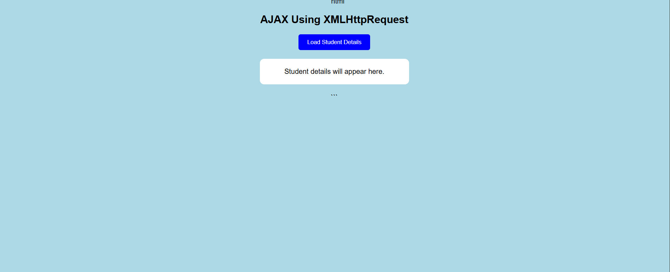

4. Student Management System Using TypeScript Class and Object

Aim
To develop a TypeScript program using a class and object to represent student details, including name, register number, department and marks. The program should include properties, a constructor and a method to display student information.

1. Introduction to TypeScript
TypeScript is a superset of JavaScript developed by Microsoft.
It supports:
- Static typing
- Classes and objects
- Constructors
- Inheritance
- Interfaces
- Access modifiers
TypeScript code is converted into JavaScript before execution.

2. TypeScript Program

class Student {
// Properties
name: string;
registerNumber: number;
department: string;
marks: number;

// Constructor
constructor(name: string, registerNumber: number,
department: string, marks: number) {

this.name = name;
this.registerNumber = registerNumber;
this.department = department;
this.marks = marks;

}

// Method to display student details
displayStudent(): void {

console.log("STUDENT DETAILS");
console.log("---------------------");

console.log("Name: " + this.name);
console.log("Register Number: " + this.registerNumber);
console.log("Department: " + this.department);
console.log("Marks: " + this.marks);

}
}
// Creating an object
let student1 = new Student(
"Arun Kumar",
123456,
"Computer Science",
95
);
// Calling the method
student1.displayStudent();

3. Explanation
1. Class
The Student class acts as a blueprint for creating student objects.
2. Properties
The class contains four properties:
- name – Stores the student's name.
- registerNumber – Stores the register number.
- department – Stores the department name.
- marks – Stores the student's marks.
3. Constructor
The constructor initializes the student properties when an object is created.
4. Method
The displayStudent() method displays the student information.
5. Object
The student1 object is created using the new keyword.

4. Output
STUDENT DETAILS
---------------------
Name: Arun Kumar
Register Number: 123456
Department: Computer Science
Marks: 95

5. Advantages of TypeScript
- Provides static type checking.
- Reduces programming errors.
- Supports object-oriented programming.
- Improves code readability.
- Makes large applications easier to maintain.

Result
Thus, the Student Management System is successfully implemented using TypeScript classes, objects, properties, constructors and methods.


5. Online Banking Form Validation Using JavaScript and Regular Expressions

Aim
To develop a JavaScript-based form validation system for an online banking application using Regular Expressions to validate account number, mobile number and email ID.

Program
<!DOCTYPE html>
<html>
<head>
<title>Online Banking Validation</title>
</head>
<body>
<h2>Online Banking Registration</h2>
<form id="bankForm">
Account Number:
<input type="text" id="account">
<span id="accountError" style="color:red"></span>
<br><br>

Mobile Number:
<input type="text" id="mobile">
<span id="mobileError" style="color:red"></span>
<br><br>

Email ID:
<input type="text" id="email">
<span id="emailError" style="color:red"></span>
<br><br>

<button type="submit">Submit</button>
</form>
<h3 id="result" style="color:green"></h3>
<script>
document.getElementById("bankForm").addEventListener("submit", function(event) {
event.preventDefault();
let account = document.getElementById("account").value;
let mobile = document.getElementById("mobile").value;
let email = document.getElementById("email").value;
let valid = true;
// Regular Expressions
let accountPattern = /^\d{10,16}$/;
let mobilePattern = /^[6-9]\d{9}$/;
let emailPattern = /^[a-zA-Z0-9._%+-]+@[a-zA-Z0-9.-]+\.[a-zA-Z]{2,}$/;
// Account Number Validation
if (!accountPattern.test(account)) {
document.getElementById("accountError").innerHTML =
"Enter valid account number (10-16 digits)";
valid = false;
} else {
document.getElementById("accountError").innerHTML = "";
}
// Mobile Number Validation
if (!mobilePattern.test(mobile)) {
document.getElementById("mobileError").innerHTML =
"Enter valid 10-digit mobile number";
valid = false;
} else {
document.getElementById("mobileError").innerHTML = "";
}
// Email Validation
if (!emailPattern.test(email)) {
document.getElementById("emailError").innerHTML =
"Enter valid email ID";
valid = false;
} else {
document.getElementById("emailError").innerHTML = "";
}
// Final Validation
if (valid) {
document.getElementById("result").innerHTML =
"Bank Registration Successful!";
} else {
document.getElementById("result").innerHTML = "";
}
});
</script>
</body>
</html>

Regular Expressions Used

Field | Regular Expression | Description
Account Number | ^\d{10,16}$ | Accepts 10 to 16 digits
Mobile Number | ^[6-9]\d{9}$ | Accepts valid 10-digit Indian mobile numbers
Email ID | ^[a-zA-Z0-9._%+-]+@[a-zA-Z0-9.-]+\.[a-zA-Z]{2,}$ | Checks valid email format

Output
Case 1: Valid Details
- Account Number: 123456789012
- Mobile Number: 9876543210
- Email ID: arun@gmail.com
Output:
Bank Registration Successful!
Case 2: Invalid Details
- Account Number: 12345
- Mobile Number: 123456
- Email ID: arun@gmail
Output:
- Enter valid account number (10–16 digits).
- Enter valid 10-digit mobile number.
- Enter valid email ID.

Explanation
- The user enters banking details in the form.
- JavaScript retrieves the input values using DOM methods.
- Regular Expressions validate the entered information.
- Invalid inputs display appropriate error messages.
- The preventDefault() method prevents page reloading.
- If all inputs are valid, a success message is displayed.

Result
Thus, the online banking form validation system is successfully developed using JavaScript, DOM manipulation and Regular Expressions.


